**Instructions**

Executable included inside the archive, **DOUBLE CLICK** to execute.

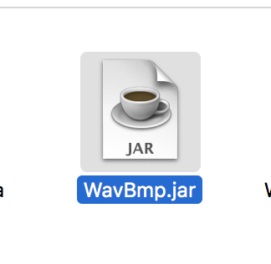

This shows the commands you use to create the above WavBmp.jar for your own reference, please be in the same folder as the source files before running commands

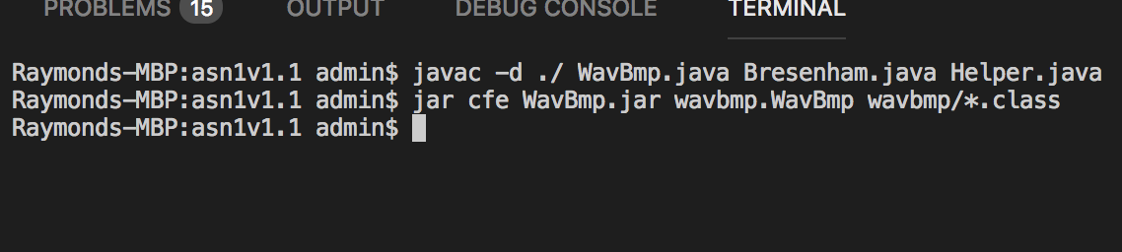

The program is very simple, there are three areas that you only need to know about.

1. The “Open File…” button opens a dialog for the user to search and select a WAV or BMP file to load.
2. The “Lossy” toggle button has two options and is reserved for BMP files that are loaded into my program. The first option “Lossy” is enabled by default and the second option “Lossless” is enabled only when you click the toggle button. The purpose is self-explanatory, but it basically allows the user to choose between two modes of compression which output either an IM3 or IN3 file depending on compression choice.
3. The compression ratio for either Huffman or LZW, note that for both IN3 and IM3 compression they use Huffman Compression.

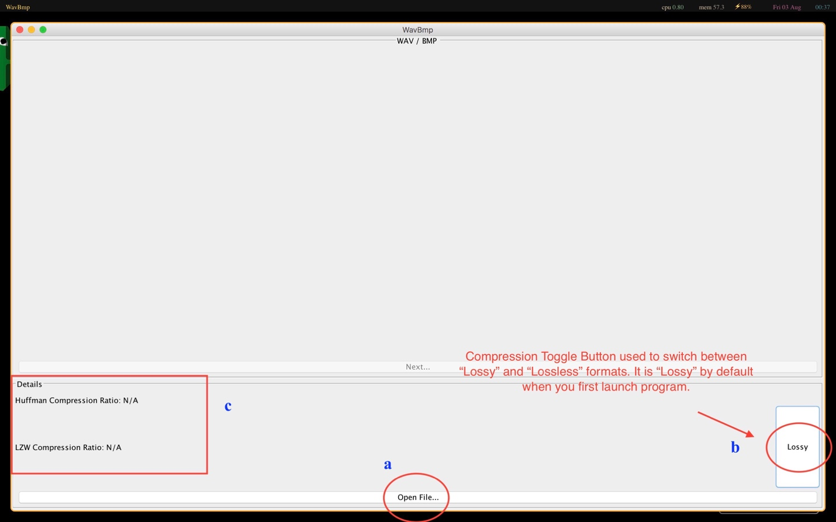

**Sample Output**

**WAV INPUT**

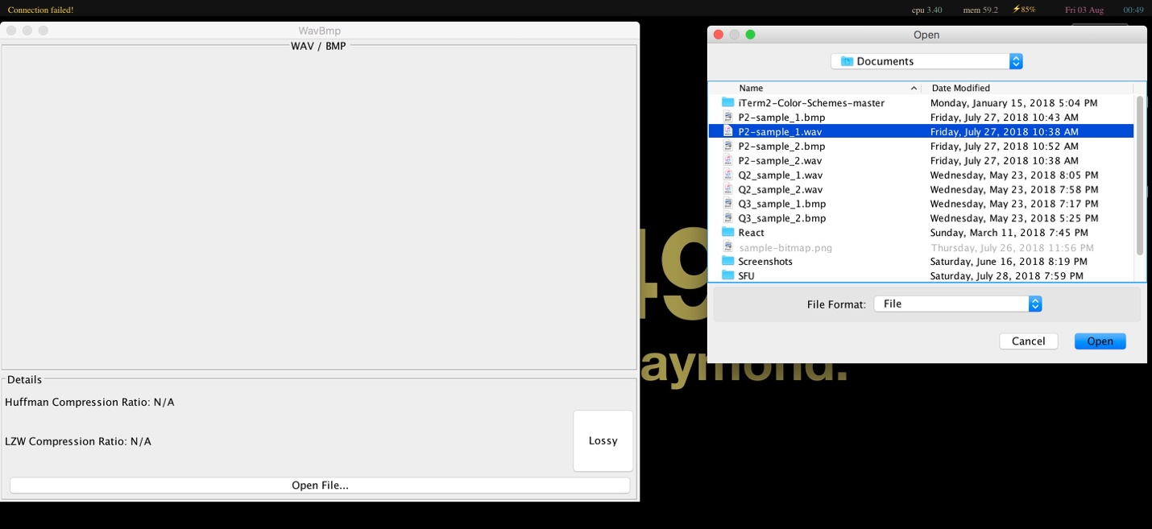

**WAV COMPRESSION RATIO**

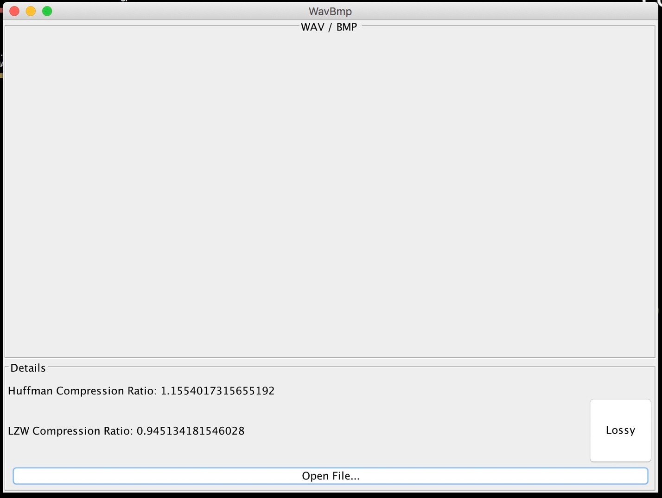

**LOSSY MODE BMP INPUT**

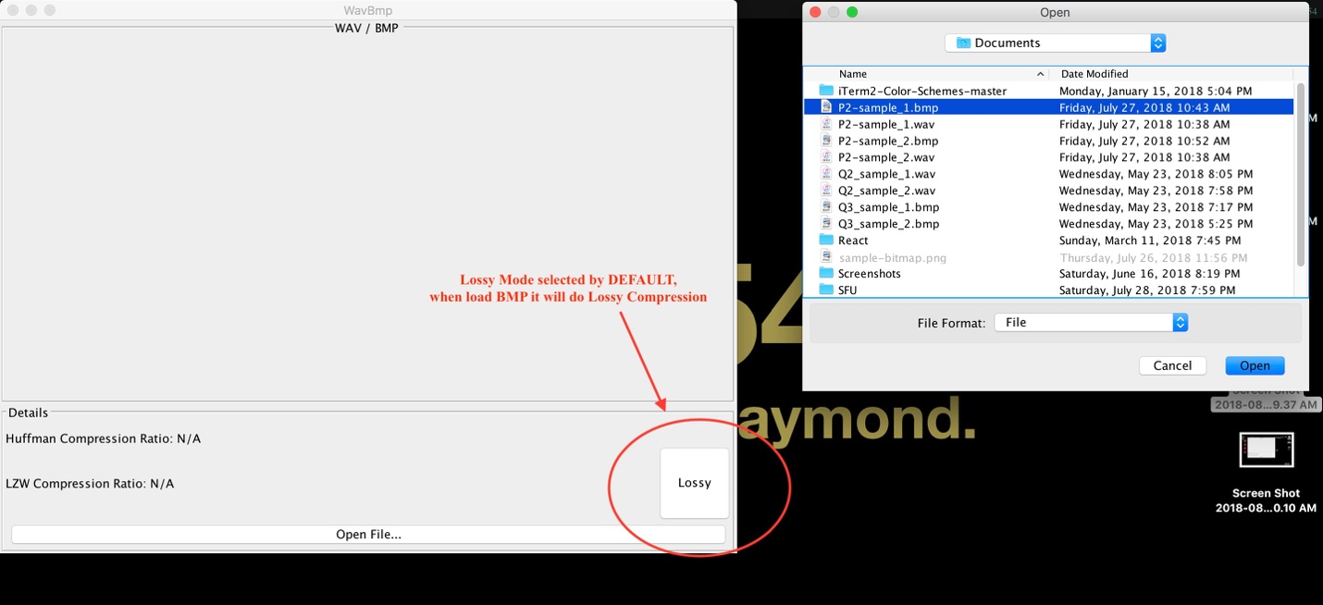

**LOSSY MODE BMP OUTPUT**

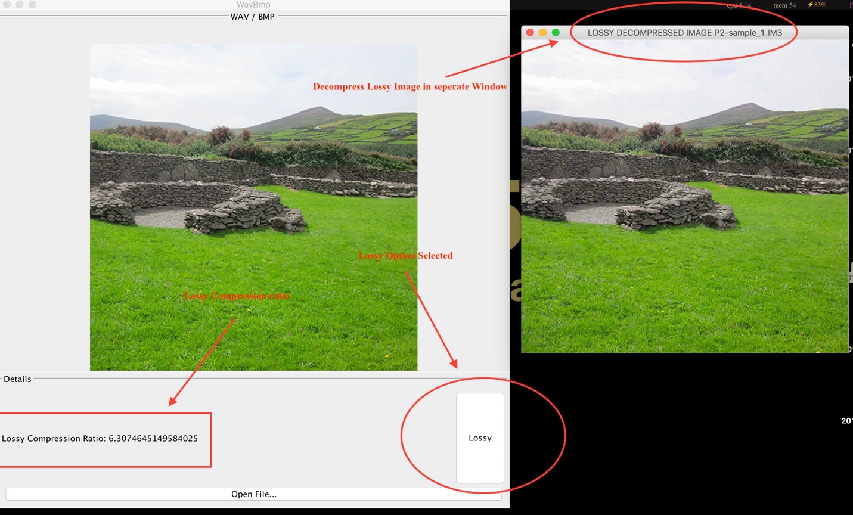

**LOSSLESS MODE BMP INPUT**

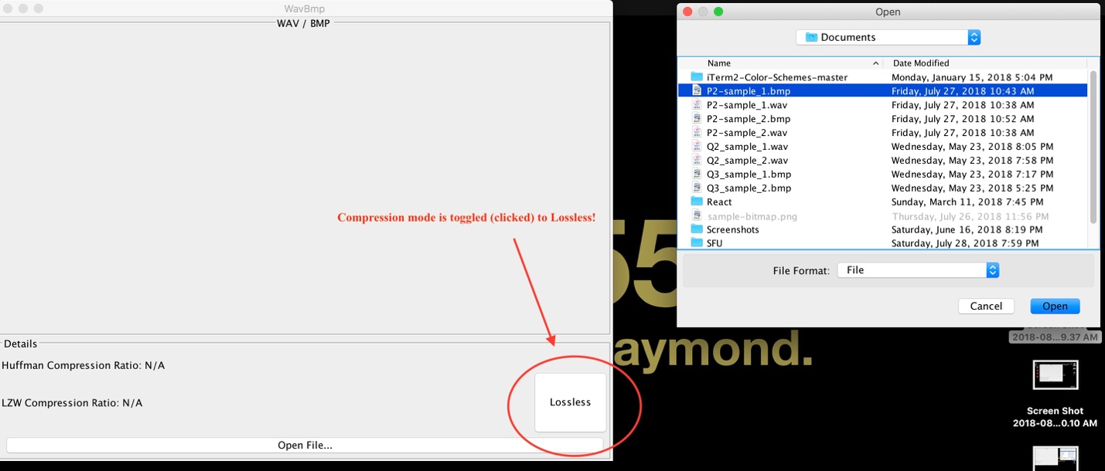

**LOSSLESS MODE BMP OUTPUT**

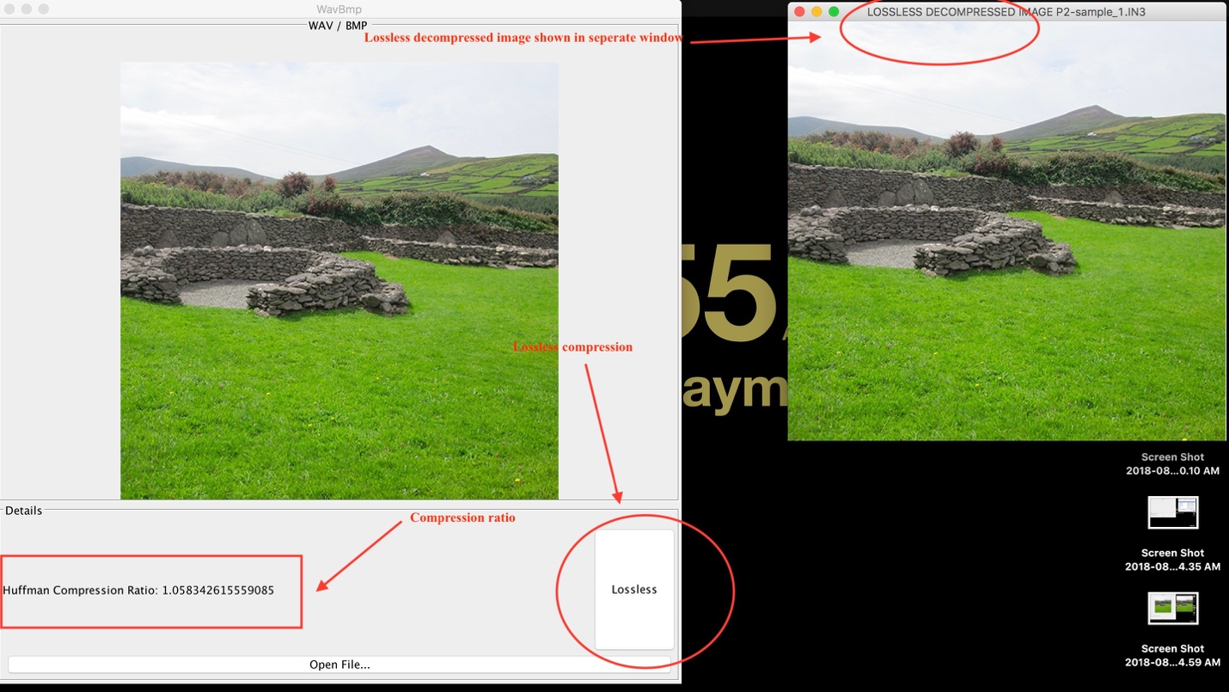

**IM3 INPUT**

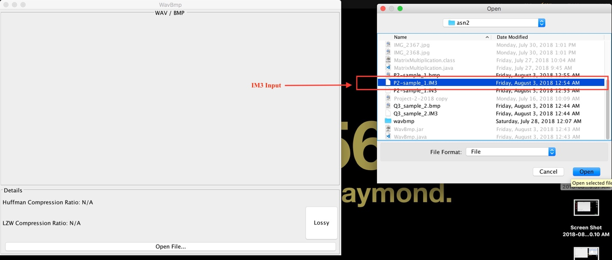

**IM3 OUTPUT**

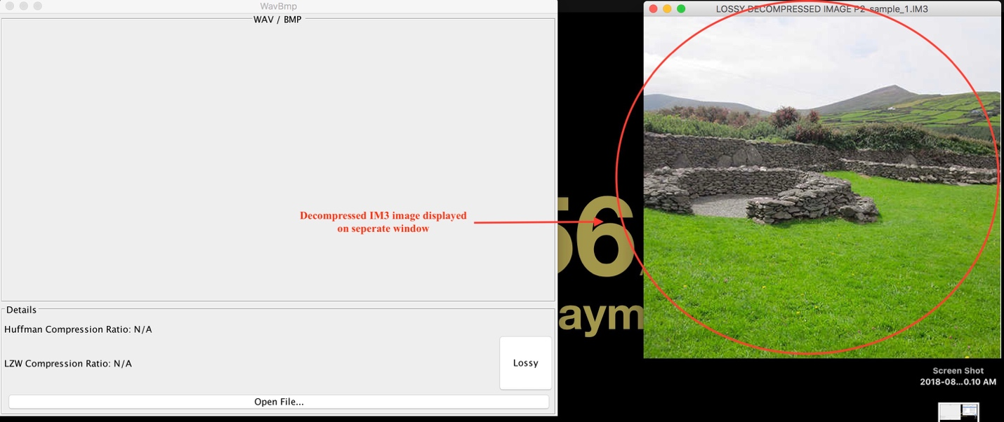

**IN3 INPUT**

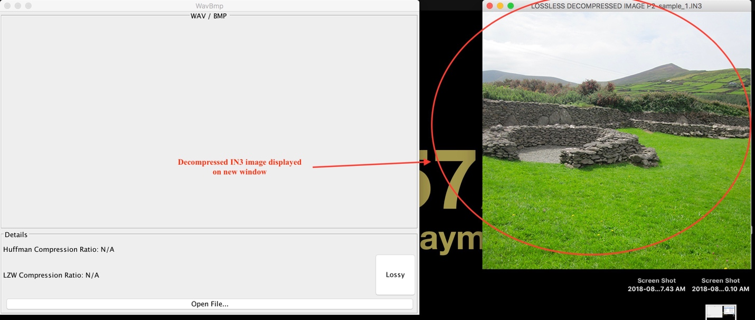

**IN3 OUTPUT**

